**BANK LOAN POWER BI & SQL PROJECT**

**1 . Total Loan Applications**

SQL QUERY –

select count(*)

from bankr;

SQL Result –



**2 . Total Loan Amount Sanctioned**

SQL Query –

select sum(loan_amount) as Total_Loan_Amount

from bankr;

Result



**3 . Average Interest Rate**

SQl Query

select Round(Avg(int_rate),2) * 100 as Average_interest_rate

from bankr;

Result



**4 Total Good Loan Applications**

select count(id)

from bankr

where loan_status='Fully Paid' or loan_status='Current'



**5 Good Loan Funded Amount**

Sql Query

select sum(loan_amount) as Good_loan_funded_amount

from bankr

where loan_status='Fully Paid' or loan_status='Current';

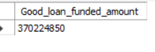

**6 Total Amount Received from good loan**

select sum(total_payment) as Good_amount_recevied

from bankr

where loan_status='Fully Paid' or loan_status='Current';



**7 Bad Loan Percentage**

**select round((count(case when loan_status = 'Charged Off' Then id end)*100),3)/count(id) as Bad_loan_Percentage**

**from bankr;**

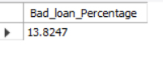

**8 Good Loan Percentage**

**select (count(case when loan_status = 'Fully Paid' Or loan_status = 'Current' Then id end)*100)/count(id) as Good_loan_Percentage**

**from bankr;**

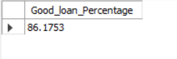

**9 Total Bad Loan Applications**

**select count(*)**

**from bankr**

**where loan_status='Charged Off';**

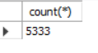

**12 Total Amount Funded**

**select sum(loan_amount) as Total_Funded_Amount**

**from bankr**

**where loan_status='Charged Off'**



**11 Total Received Amount From Bad Loans**

**select sum(total_payment) as Good_amount_recevied**

**from bankr**

**where loan_status='Charged Off'**



**12 Loan Status**

**SELECT loan_status,**

**COUNT(id) AS LoanCount,**

**SUM(total_payment) AS Total_Amount_Received,**

**SUM(loan_amount) AS Total_Funded_Amount,**

**AVG(int_rate * 100) AS Interest_Rate,**

**AVG(dti * 100) AS DTI**

**FROM bankr**

**GROUP BY loan_status**

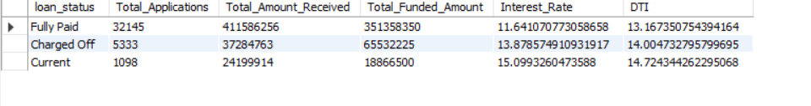**13 Loans based on Home**

**select home_ownership,**

**count(id) as Total_Loan_Applications,**

**sum(loan_amount) as Funded_Amount,**

**sum(total_payment) as Repaid_Amount**

**from bankr**

**group by 1 order by Total_Loan_Applications desc ;**

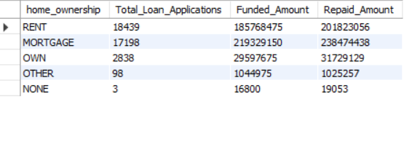

**14 Employee Length**

**SELECT emp_length AS Employee_Length,**

**COUNT(id) AS Total_Loan_Applications,**

**SUM(loan_amount) AS Total_Funded_Amount,**

**SUM(total_payment) AS Total_Amount_Received**

**FROM bank_loan_data**

**GROUP BY emp_length**

**ORDER BY emp_length**

**RESULT**

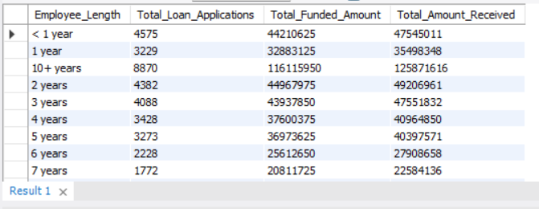

**15 State wise Loan Analysis**

**SELECT address_state AS State,**

**COUNT(id) AS Total_Loan_Applications,**

**SUM(loan_amount) AS Total_Funded_Amount,**

**SUM(total_payment) AS Total_Amount_Received**

**FROM bankr**

**GROUP BY address_state**

**ORDER BY address_state;**

**RESULT**

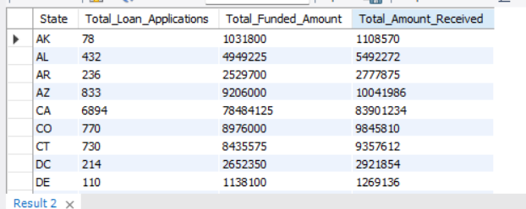

**16 Purpose wise Loans**

**SELECT purpose AS PURPOSE,**

**COUNT(id) AS Total_Loan_Applications,**

**SUM(loan_amount) AS Total_Funded_Amount,**

**SUM(total_payment) AS Total_Amount_Received**

**FROM bankr**

**GROUP BY purpose**

**ORDER BY purpose;**

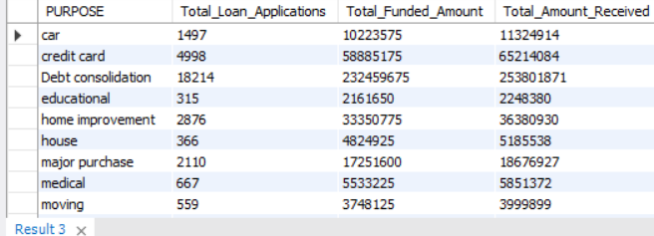

**17 Home ownership wise loan**

**SELECT home_ownership AS Home_Ownership,**

**COUNT(id) AS Total_Loan_Applications,**

**SUM(loan_amount) AS Total_Funded_Amount,**

**SUM(total_payment) AS Total_Amount_Received**

**FROM bank_loan_data**

**GROUP BY home_ownership**

**ORDER BY home_ownership;**

